**Entity Relationship Diagram (Mobile)**

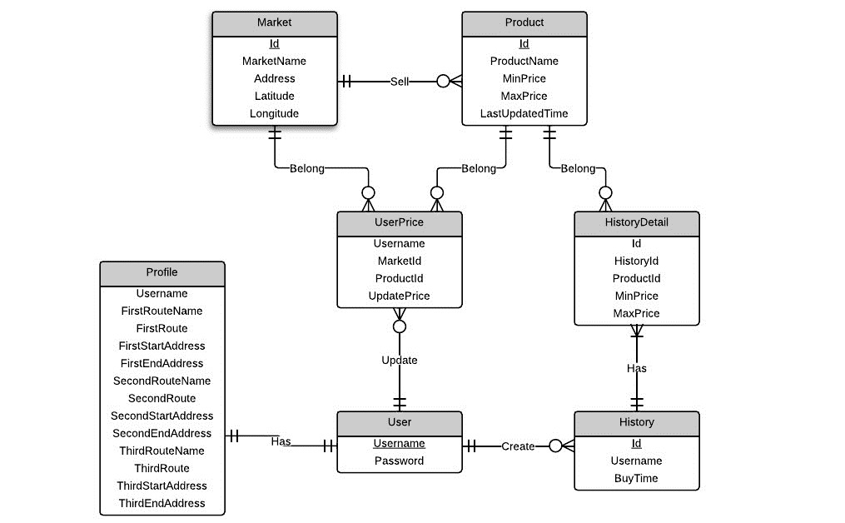

Estimate size of records in database:

* Table Market

|  |  |  |
| --- | --- | --- |
| **Attribute** | **Type** | **Size (bytes)** |
| Id | Integer | 4 |
| MarketName | Text | 8 |
| Address | Text | 8 |
| Latitude | Text | 8 |
| Longitude | Text | 8 |
| 36 | | |
| 100 records: 3600 | | |

* Table Product

|  |  |  |
| --- | --- | --- |
| **Attribute** | **Type** | **Size (bytes)** |
| Id | Integer | 4 |
| ProductName | Text | 8 |
| MinPrice | Integer | 4 |
| MaxPrice | Integer | 4 |
| LastUpdatedTime | Text | 8 |
| 28 | | |
| 300 records: 8400 | | |

* Table User

|  |  |  |
| --- | --- | --- |
| **Attribute** | **Type** | **Size (bytes)** |
| Username | Text | 8 |
| Password | Text | 8 |
| 16 | | |
| 1 records: 16 | | |

* Table UserPrice

|  |  |  |
| --- | --- | --- |
| **Attribute** | **Type** | **Size (bytes)** |
| Username | Text | 8 |
| MarketId | Integer | 4 |
| ProductId | Integer | 4 |
| UpdatePrice | Integer | 4 |
| 20 | | |
| 5 records: 100 | | |

* Table History

|  |  |  |
| --- | --- | --- |
| **Attribute** | **Type** | **Size (bytes)** |
| Id | Integer | 4 |
| Username | Text | 8 |
| BuyTime | Text | 8 |
| 20 | | |
| 30 records: 600 | | |

* Table HistoryDetail

|  |  |  |
| --- | --- | --- |
| **Attribute** | **Type** | **Size (bytes)** |
| Id | Integer | 4 |
| HistoryId | Integer | 4 |
| ProductId | Integer | 4 |
| MinPrice | Integer | 4 |
| MaxPrice | Integer | 4 |
| 20 | | |
| 300 records: 6000 | | |

* Table Profile

|  |  |  |
| --- | --- | --- |
| **Attribute** | **Type** | **Size (bytes)** |
| Username | Text | 8 |
| Password | Text | 8 |
| FirstRouteName | Text | 8 |
| FirstRoute | Text | 8 |
| FirstStartAddress | Text | 8 |
| FirstEndAddress | Text | 8 |
| SecondRouteName | Text | 8 |
| SecondRoute | Text | 8 |
| SecondStartAddress | Text | 8 |
| SecondEndAddress | Text | 8 |
| ThirdRouteName | Text | 8 |
| ThirdRoute | Text | 8 |
| ThirdStartAddress | Text | 8 |
| ThirdEndAddress | Text | 8 |
| 112 | | |
| 1 records: 112 | | |

Total size of database: 18828 bytes $≈$ 18.4 kb